7.16

最近follow political events能看出来人民的智商普遍比较低,容易manipulate.

任何有很强political position的人都很容易被利用. 智商都会急剧下降.

以至于基本的逻辑思考都没法进行.

这种人绝对不是少数, 而是多数. 比如肇事者, 跟交警抬杠, 激怒交警, 很固执不下车, 无法进行理性思维, 很容易被玩死. 智商不高.

这次ink事件, 现实

7.17 Tue, Shenzhen, Cloudy

Markets are highly volatile.

Front month atm vol is at 25v.

This kind of vol cannot sustain a bull market.

7.19

Overnight autolog

1. Keep track of crosses
2. Keep track of MA slow and fast values

Overnight trader should be replaced by percentile ma trader.

Current overnight trader only applies from 3-5.

Observing MA touch – only report crosses. Not every single minute.

O/N reporting:

Work on getWeekdayAdjustment.

Monday intraday+overnight ->

7.20.2018

Volatility is huge.

No bull market works like this, rising like a short squeeze.

Delta switched to bullish delta (+500,000) because index broke 20DMA.

Insurance and banks were up 3-10% on deregulation news.

Overall,

1. China underperforms all world markets in the long run
2. Fake and fraudulent accounting, lot of small stocks are timer bombs waiting to explode
3. High volatility
4. Chinese pay the most expensive price for living necessities like a place to stay, food, education, medcare, etc.

**Weekly review:**

Stocks: -4k

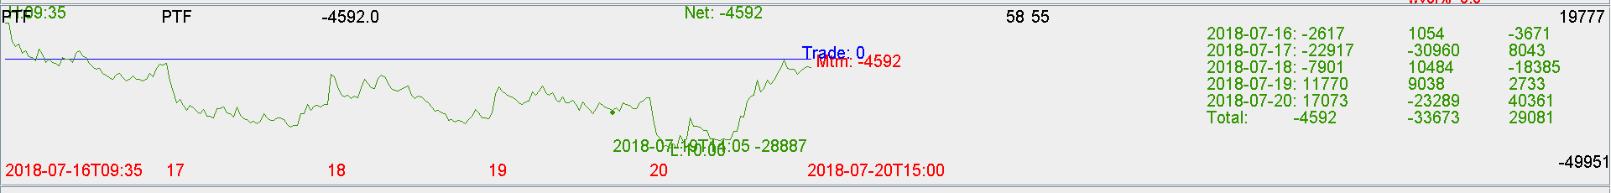

Futures: Flat

Trading this week is done well.

No trimming.

Trading is spaced out, at the correct places.

Mtm was down -15k, trade was up 20k.

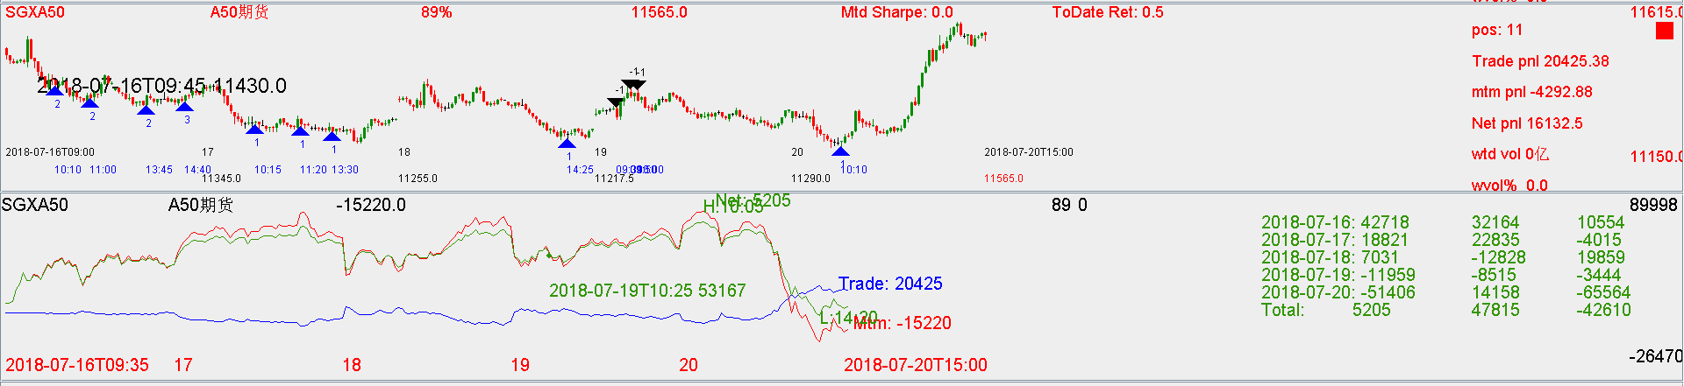

Overall:

Flattish.

**Whole of July:**

Ptf is down 1% in july.

Markets are very volatile, this kind of return is not bad.

Trading pnl is improving.

**May to Jul:**

Flat pnl.

**Improvements:**

Keep percentileMAtrading as it works.

Take risk wherever needed.

Don’t take market liquidity, only offer liquidity.

Offer opportunities for markets to chase trend.

**On markets**

Markets are a scam as usual.

Markets in the long term are bearish as regulation sucks and companies suck.

Smart money don’t buy the story that stimulus will help with the Chinese economy.

With FX like this, any stock market reprieve will be a chance to get out.